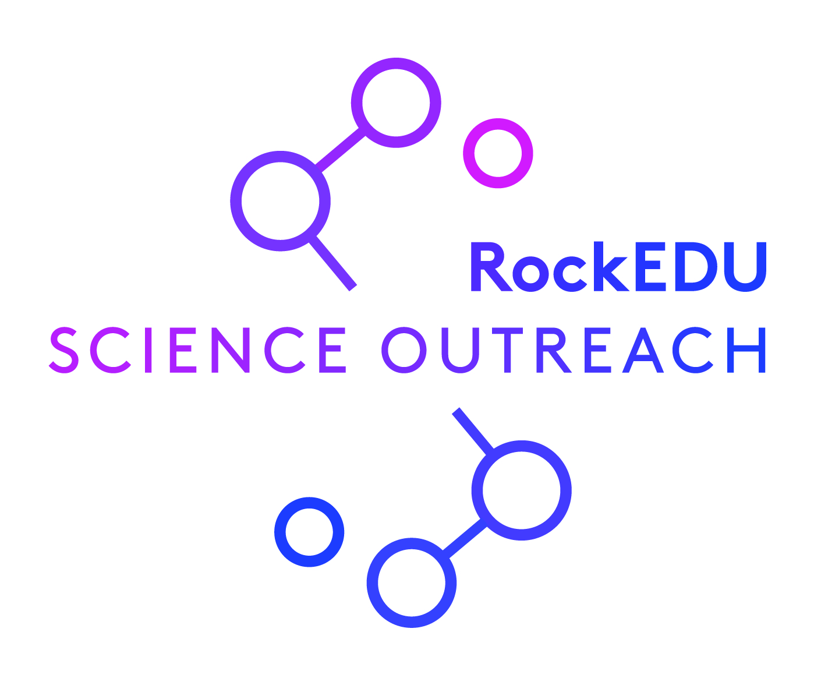
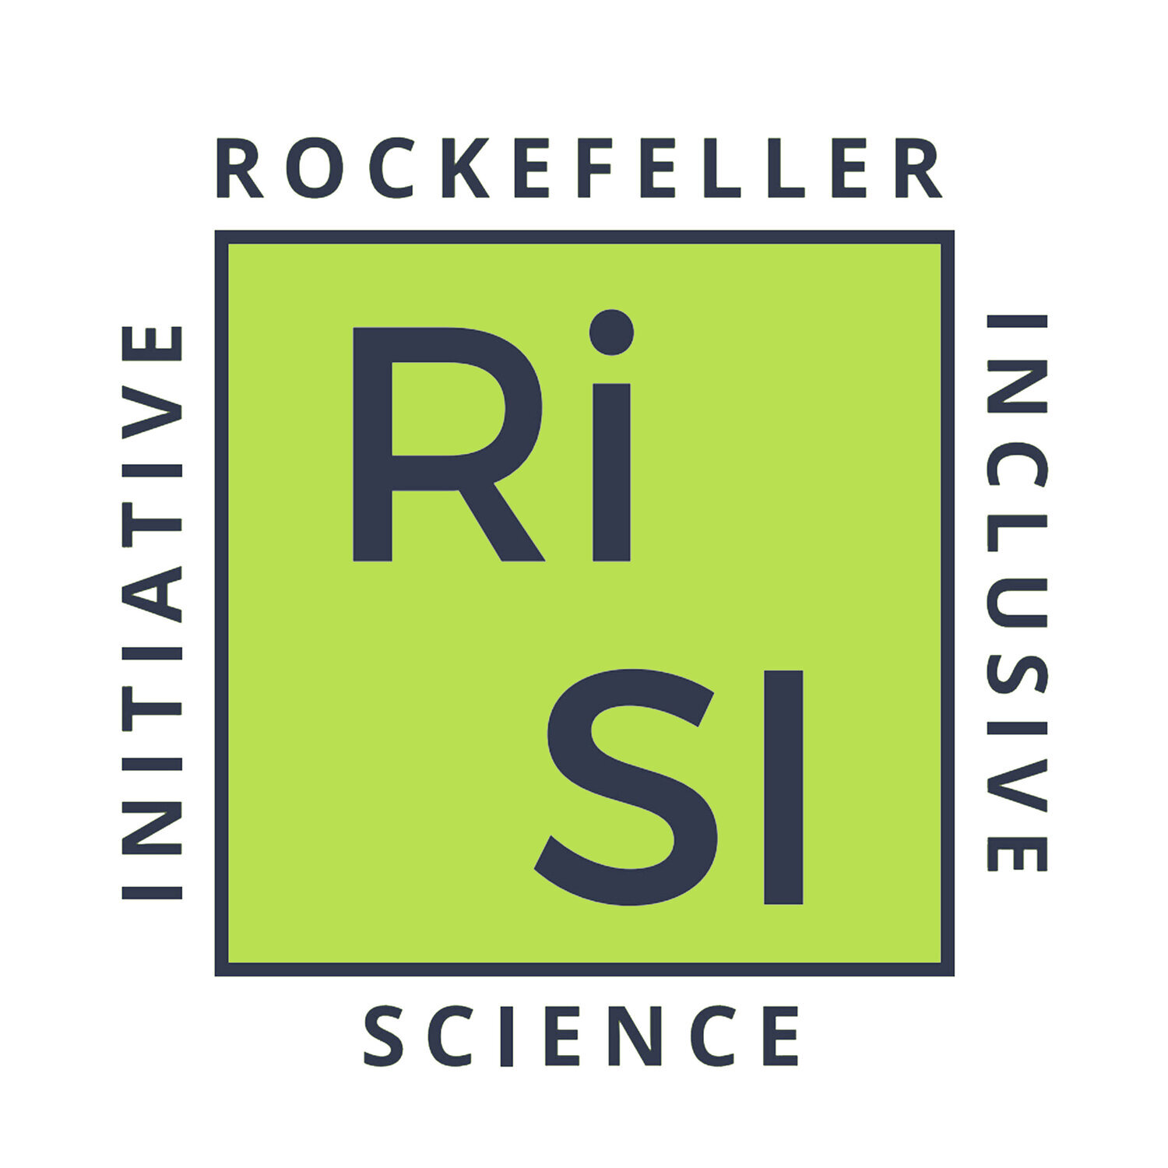
What does it mean to be a "good" scientist?! answer key

An exercise on spotting scientific gatekeeping

Please turn on ‘track changes’ to see the answers as written by authors of the exercise. We request that you keep this document in its original form and present it in its entirety. Please do not repurpose this content for use outside of the activity.

In this activity, participants are split into two groups where they will address one of two prompts (either: Caleb & Maya or Sam & Maria).

Each prompt is accompanied by:
- Articles: Specific articles were selected to frame the discussion and get participants to start thinking about how skills that differ from those traditionally valued can contribute to success in science.
- Case Study: Two examples of problematic behavior in mentorship are shared here. Items here vary from overtly discriminatory to more nuanced microaggressions.
- Case Study Answers (shared only in answer key): Within each case study shared in the answer key, you'll find our track changes that include all of the interactions/behaviors that we "flagged" as problematic or felt were important things to highlight and keep an eye on!
- Contextualization (shared only in answer key): After each case study, we share both the broader idea behind why these scenarios were selected as well as the specific barriers that were addressed in these examples. None of these areas where barriers may arise are reflective of whether someone is “good” at science. Yet, failing to accommodate individuals based on these areas (and identities) may dictate who decides to pursue science and who is made to believe that science is not for them. By maintaining a narrow focus on who can do science and what success looks like, we are disadvantaging anyone who falls outside of what a mentor considers “normal”.
- Discussion Questions: Discussion questions are posed as a takeaway for each case study and any opportunity to get to the root of the problematic behaviors and the appropriate actions that a mentor should take in these situations.

Activity Instructions:
- In small groups read the shared articles. (~5 minutes)
- Go through a case study with your group mates using track changes. Add comments to the case study on the behaviors and events that feel problematic and ultimately contribute to scientific gatekeeping. As you work through this, chat with your team members about where you see signs of the mentor deciding what “good science” is. (~10 minutes)
- Spend some time working through the discussion questions and figuring out what steps a mentor should take to promote multiple “ways of knowing” in science. (~5 minutes)
- If you have split up into smaller groups for this activity, share your reflections to your case studies with your larger group. After all perspectives have been shared, key takeaways surrounding core questions can be answered in Padlet. Here is an example of the questions that BIOME and RiSI discussed.

Case study 1: Caleb and Maya
Case study 2: Maria and Sam

Caleb & Maya
Article:
“How managing a chronic illness gave me skills that would strengthen my PhD”
“How pirouettes and pliés prepared me for a research career”

Case study:
Caleb is mentoring a high school student named Maya. Maya is passionate about a range of things including: Physics, soccer, and reading science fiction novels. Maya is currently enrolled in a New York City DOE public school and immigrated to the U.S. 3 years ago with her family. Caleb is a first-time mentor and is eager to show Maya how science should be done. When they first meet, Caleb tells Maya about himself and shows her around the lab space. Maya will be joining Caleb’s existing group of mentees—all of whom are born and raised in New York City. Maya is so thrilled to finally have the chance to study her passion at her dream institution, but every time she shares her desire to become a physicist, Caleb reminds her that “physics isn’t for everyone” and that she may prefer Biology. Maya feels hurt by this—all of her teachers have marveled at how quickly she understands core principles of Physics and her infectious energy during class discussions—but respecting authority is a core principle that her parents instilled in her, so she does not push back. Every month Maya has a lab meeting with her mentor and fellow mentees where they share their progress as written via short summary. Maya reads hers aloud, and some of her labmates snicker—she mixed up her verb tenses again. Maya speaks 3 languages, and sometimes she mixes things up. She wishes that she could get some 1-1 time with Caleb so that she could share her summaries in a way that feels more comfortable, but Caleb feels strongly about treating everyone equally, so instead of talking with Caleb about other ways to share her progress, Maya decides to spend some time after lab practicing grammar exercises. She continues to excel in her studies and be a voracious reader, but research in practice just isn’t working out. Being a first generation college student, she doesn’t have much direction at home, and she wonders if maybe she was wrong about science being for her.

Contextualizing the case study:
This study was designed to pinpoint three areas that may present a “barrier to entry” for someone entering science. Three areas were:
- Cultural background/identity
- Speaking English as a second (or third or fourth!) language
- Difficulty with public speaking

In this piece, Maya is passionate about Physics, yet through repeated negative interactions with Caleb—that have no relation to her actual scientific success—she is made to question her place in science and feel insecure about her capabilities. Throughout this piece, we highlight the missed opportunities to support Maya’s identity.

Discussion Questions:
- In thinking about what "good science” means, how do you think Caleb defines good science?
- What would make Caleb a stronger mentor?
- What advice would you give Maya in this situation?
- What does it mean to “treat everyone equally”, and how does this play a role in equitable mentorship?
- What are some takeaways you have from this discussion?

Sam & Maria
Article:
“How managing a chronic illness gave me skills that would strengthen my PhD”
“How pirouettes and pliés prepared me for a research career”

Case study:
Sam is an undergraduate student interested in scientific research, but has never had the opportunity to do research before. They apply for a summer research position working with Maria, a postdoctoral fellow who is excited to teach and mentor the next generation of scientists. When reading through applications, Sam’s application stands out due to their enthusiasm for science, but upon further review Maria realizes that their grades are not to the same level as other applicants. After meeting with a few of the other students who applied, Maria decides to interview Sam, as they seemed the most excited about the research opportunity in their application. During the interview, Maria asks Sam about their career goals, and they say that they are interested in pursuing a career in scientific research. Maria asks about Sam’s grades, specifically in classes related to the research topic. Sam describes how they have been working long hours while attending school. Maria asks Sam if they would need to work an additional job along with working in the lab, and Sam says that they are not sure and it would depend on the stipend. Maria asks Sam about their job, and Sam describes that through that job they have developed their ability to manage time and multi-task. After the interview, Maria reflects on all the candidates and realizes that Sam was the only applicant she interviewed who is interested in a career in scientific research. However, Maria is not sure if the position is the best fit for Sam because the stipend is not enough money to live off of. Maria is also worried that Sam might not be able to relate to the other undergraduate students working in the lab, who have much more experience and often work extra hours to make progress on their experiments.

Contextualizing the case study:
The inspiration behind this case study was the idea that students can gain skills outside of traditional academics (ie courses/ grades) that are incredibly useful in the lab. Some barriers to entry in academia highlighted in this case study include:
- Ability to work for free/ limited stipend
- Emphasis on grades/ testing
- Being a good “fit” for a lab culture

In this case study, Maria has a deficit-focused mindset and focuses on Sam’s grades and socioeconomic status rather than acknowledging the transferable skills that Sam could bring to the lab. We highlight how this approach could prevent Sam from getting to join a lab despite being passionate about research.

Discussion Questions:
- In thinking about what "good science” means, how do you think Maria defines good science?
- What would make Maria a stronger mentor?
- If you were interviewing Sam, what questions would you want to include in your interview?
- How would you mentor Sam in the lab?
- How can Maria foster a more inclusive lab environment?
- What are some takeaways you have from this discussion?

